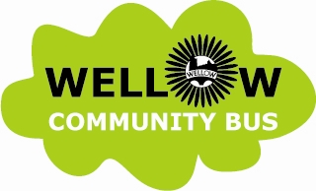
Wellow Community Bus Hire Form

Terms and Conditions:
Any parking/speeding fines or congestion charges are the sole liability of the user. User information will be passed on to the relevant authorities. Any congestion charges must be paid by the user prior to the journey and are not the responsibility of the Wellow Community Bus Committee. The bus must be returned in a clean state; if it is returned in a less than satisfactory state the user will be charged a nominal fee for cleaning.
The driver of the bus must be approved by the Wellow Community Bus Committee.
Cost is £50 per booking for up to 25 miles with an additional £2 a mile thereafter and includes fuel. Note that the driver is paid separately by the hirer.
Please complete Part A of this form to book the bus. Then complete Part B after the hire and return it along with electronic payment within one week of your journey. Prakriti Karthauser (Wellow Community Bus Group committee member) is your point of contact.

Part A: Details of hire to be completed in advance to book the bus
Hirer’s Name
Hirer’s Tel No
Hirer’s Address

Date of planned hire
Destination & Purpose

Driver’s Name
Driver’s Tel No

Part B: Details to be completed after journey and submitted with payment.
Start & End Mileages
Total Miles Travelled
Date of travel
No of Passengers
Total cost | £

